MACHINE LEARNING USING BANK MARKETING DATA
Team 1, ECE 552 Big Data Technologies, Fall 2023

Carlos Daing
GMU, DAEN
cdaing@gmu.edu
Richa Saraf
GMU, DAEN
rsaraf@gmu.edu
Satyam Singh
GMU, DAEN
ssingh88@gmu.edu

Abstract— In this project, we harness the power of machine learning and big data technologies through the analysis of a dataset from a prominent Portuguese banking institution. Focused on direct marketing campaigns, the dataset encapsulates crucial client interactions, offering a comprehensive view of customer behavior. Our objective is to construct a predictive model that discerns the factors influencing client subscription to term deposits. Employing data preprocessing, feature engineering, and machine learning algorithms, we aim to accurately forecast subscription likelihood. Leveraging Apache Spark for distributed computing, we demonstrate the scalability and efficiency of big data processing. The model achieved high accuracy and F1-scores. These metrics affirm the predictive performance of the model and highlight its interpretability, shedding light on influential factors steering client decisions. This project provides a model that enriches the bank's marketing strategies and contributes to a deeper understanding of customer dynamics in the realm of term deposit subscriptions. The combination of scalable computing and machine learning positions itself as a powerful force in the data-driven decision-making landscape of bank marketing.
Keywords—Machine Learning, PySpark, Juypter, Parquet, MongoDB

Introduction
In recent years, the field of machine learning has witnessed unprecedented growth and has become an integral part of data-driven decision-making processes across various industries [1]. This paper delves into the realm of machine learning by leveraging the power of PySpark, a distributed computing framework, for the analysis of a prominent dataset derived from the Portuguese banking sector.
The primary objective of this project is to develop an effective model capable of predicting term deposit subscriptions based on diverse client attributes. Leveraging PySpark's distributed computing capabilities, the focus then shifts to the implementation of a decision tree classifier, a transparent and interpretable algorithm well-suited for binary classification tasks. The next goal is to assess the model's predictive performance and its ability to discern client behaviors regarding term deposit subscriptions. Some key questions the project attempts to address:
- Will a client subscribe to a term deposit based on their demographic and financial characteristics?
- How does the interpretability and performance of the decision tree model contribute to understanding client behaviors?
- To what extent does PySpark enhance the scalability and efficiency of the machine learning pipeline, particularly in handling large-scale banking datasets?

Literature Review
The advent of big data has spurred a paradigm shift in the field of data science, necessitating scalable and efficient processing frameworks. Apache Spark has emerged as a prominent solution, providing a distributed computing environment for large-scale data processing. Numerous studies have explored the capabilities of PySpark, the Python library for Apache Spark, showcasing its versatility in handling extensive datasets and implementing complex algorithms. The seamless integration of PySpark with other data processing tools, such as MongoDB, has become a focal point for researchers and practitioners seeking efficient data management solutions [2].
Machine learning algorithms play a pivotal role in extracting meaningful insights from vast datasets. The intersection of big data and machine learning has led to the development of scalable and parallelizable algorithms capable of handling immense volumes of information. In 2022, a lab was conducted on Google Colab for Scalable Machine Learning (SML) using PySpark, aimed at facilitating research in science and engineering applications [3]. Their work emphasizes the significance of Apache Spark as a fast and scalable framework for big data analytics.
Machine learning has proven to be useful in marketing campaigns. Organizations desire to address a target demographic and enhance their marketing campaign efforts. One study proposed a transfer learning framework to address changes in customers’ behavior. Their work was compatible with different machine learning models and effective in handling common campaign data challenges [4].
Decision Tree classifiers, a popular choice for their interpretability and ease of implementation, have been extensively studied in the context of distributed computing environments. Studies have highlighted the versatility and effectiveness of decision tree classifiers in enhancing classification tasks, providing insights into their applications in diverse scenarios [5][6].The first one discusses decision trees’ effectiveness in ensemble learning [5]. The second discusses its usefulness in higher-dimensional data [6].
The financial sector has been a focal point for the application of machine learning techniques, leveraging predictive modeling for risk assessment, fraud detection, and customer behavior analysis. Previous studies have demonstrated the efficacy of machine learning in the analysis of banking data, showcasing the potential for accurate predictions and informed decision-making. Machine learning models been developed to help growing credit card fraud in the financial sector. These models find fraud patterns and offer potential for further advancements in enhancing fraud prevention strategies [7][8]. Another popular application of machine learning in finance is using predicting analytics with stock market data. Forecasting future trends in vast amounts of data will help assess risk and aid in the decision of buying and selling stocks [9][10].

Data Review
The data is related with direct marketing campaigns (phone calls) of a Portuguese banking institution. Data was collected from the UC-Irvine Machine Learning Repository [11]. Several datasets were in the repository. This project uses the most recent one: “bank-additional-full.csv.” The data was taken from 2008 to 2010. The dataset has 41188 rows and 21 variables (20 inputs and the y output). The classification goal is to predict if the client will subscribe to a term deposit (variable y).
Table 1: Variables
Variable | Datatype
age | integer
job | categorical
martial | categorical
education | categorical
default | binary
housing | binary
loan | binary
contact | categorical
day_of_week | date
month | date
duration | integer
campaign | integer
pdays | integer
previous | integer
poutcome | categorical
emp.var.rate | float
cons.price.idx | float
cons.conf.idx | float
euribor3m | float
nr.employed | float
y | binary

System Architecture and Methodology

Architecture
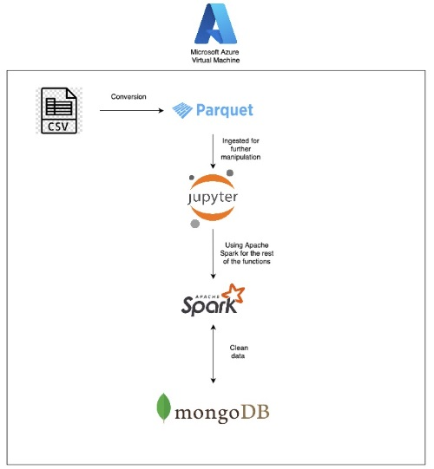
Figure 1: System Architecture
Our project unfolds on Microsoft Azure's virtual machine, serving as the backbone of our data processing pipeline. Beginning with the dataset in CSV format, the Azure VM orchestrates a seamless transition through Apache Spark for efficient preprocessing. Utilizing the distributed computing capabilities of Spark, the CSV data is transformed into the optimized Parquet format. Jupyter Notebooks, integrated with Spark, become the nexus for interactive code development and machine learning experimentation.
The project continues with the integration of MongoDB, leveraging its architecture to accommodate the dynamic data resulting from Spark's preprocessing steps. This integration creates a bridge between Spark's analytical prowess and MongoDB's flexible storage capabilities. Throughout this process, the Azure VM acts as the central computational hub, housing both the Spark and Jupyter environments. This architecture ensures scalability, efficiency, and a cohesive pipeline for transforming raw banking data into a format ready for advanced machine learning analyses. Through this integrated approach, our project seeks to unlock the full potential of distributed computing and NoSQL databases in large-scale data analytics.

Metholodogy
The machine learning pipeline in this project uses a decision tree classifier, effective in binary classification tasks. Implemented using PySpark's DecisionTreeClassifier, this algorithm recursively partitions the feature space based on the most informative features, ultimately leading to a tree structure that can make predictions on new instances. The decision tree model is chosen for its ability to handle both categorical and numerical features, providing insights into the factors influencing term deposit subscriptions.
Evaluation metrics play a pivotal role in quantifying the model's performance. The MulticlassClassificationEvaluator in PySpark computes accuracy and F1-score. Accuracy measures the proportion of correctly classified instances, while F1-score balances precision and recall, offering a holistic assessment of the model's predictive capabilities. These metrics collectively serve as benchmarks for the success of the machine learning algorithm in predicting term deposit subscriptions.

Initial Findings and Results

Data Preprocessing
In the data preprocessing phase, the raw dataset underwent a crucial transformation, transitioning from csv to Parquet format to enhance query performance and storage efficiency. The biggest challenge here was data type conversion. Since csv is text-based, the conversion to parquet created string variables. The variables were converted back manually. The column mapping process was implemented to address issues related to unreadable columns resulting from the conversion. Subsequently, null values were systematically removed from the dataset. To further facilitate preprocessing tasks, specific columns underwent a type casting process, converting them into integer types for compatibility with machine learning algorithms. Additionally, categorical columns were transformed into numerical representations utilizing the StringIndexer, a fundamental step in preparing the data for subsequent machine learning model training. These preprocessing steps collectively form a structured foundation for the downstream analyses, paving the way for insightful patterns and trends to emerge during the machine learning phase.

Connection to MongoDB
Our project framework's integration of MongoDB provided a reliable way to efficiently manage and access our data. We go into detail in this part about how to link our data pipelines to MongoDB for both data insertion and retrieval.

Writing Data into MongoDB
To make it easier to store the data that our project processed, we used PySpark to create a smooth connection with MongoDB. Our data was first prepared into an appropriate structure to be entered into the database. We converted the 'features' and 'label' columns from our final Data Frame into a format that worked with MongoDB's hierarchy. The 'features' of every row were transformed into a list while keeping a matching 'label' for future reference.

The prepared data was then added to MongoDB with PyMongo, a Python MongoDB driver. The steps in this process were connecting to the MongoDB instance, defining the collection ('BankFull') and target database ('Project_data'), and then inserting the prepared data into the appropriate collection.

Reading from MongoDB
PySpark's help, the process of getting the stored data out of MongoDB was completed without any problems. We connected to the MongoDB instance holding our stored data by setting up a SparkSession instance with the proper MongoDB input URI. Data extraction from the designated collection ('BankFull') under the 'Project_data' database was made easier by this link.

After the data was retrieved, it was organized into a Spark DataFrame, which gave us more ability to work with, process, and analyze the data in the Spark environment. To ensure compatibility and consistency with the data needs of our project, the 'features' column within the DataFrame was converted back to its original SparseVector format.

We were able to save and retrieve project data with more efficiency and scalability thanks to the integration of MongoDB with PySpark. Our project framework's expedited workflow and analysis were greatly aided by the seamless data transmission and manipulation made possible by the synergy between MongoDB and PySpark.

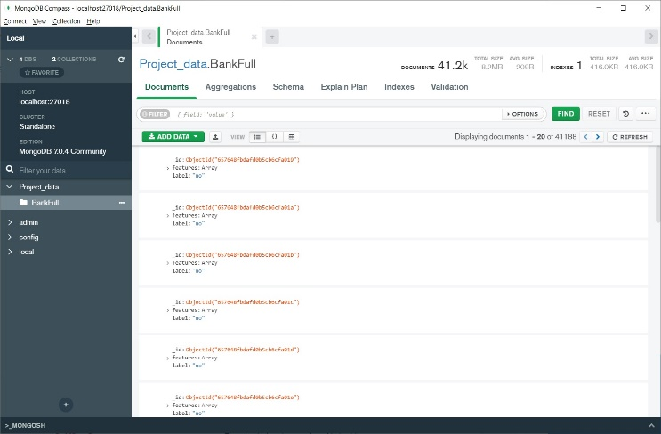

Figure 2: Connection to MongoDB

Exploratory Data Analysis
Following the seamless integration of MongoDB into our data processing pipeline, we transitioned to an in-depth exploratory data analysis (EDA) to gain valuable insights from the dataset. The visualizations provide a nuanced understanding of the dataset, including the distributions of subscribed term deposits, the diverse range of job categories, marital statuses, and education levels.

In Figure 3 below, we see that an overwhelming majority of clients did not subscribe to a term deposit.
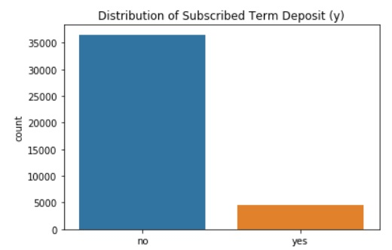
Figure 3: Distribution of Subscribed Term Deposit

In Figure 4, the job categories are shown. Most clients had administrative, blue-collar, or technical jobs.

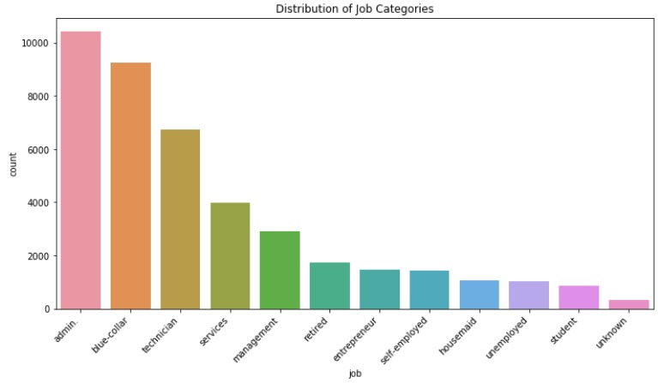
Figure 4: Distribution of Job Categories

The next figure illustrates the distribution of marital status, distribution. Most clients were married, followed by single clients, and then divorced clients.
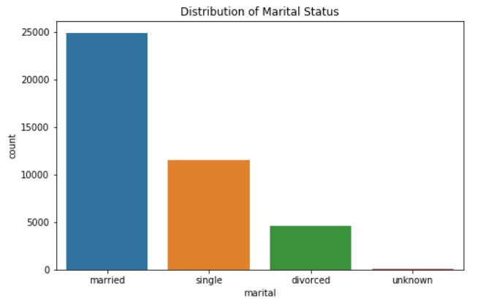
Figure 5: Distribution of Martial Status

This last EDA visualization shows the distribution of education levels. Most clients achieved a university or high school degree.

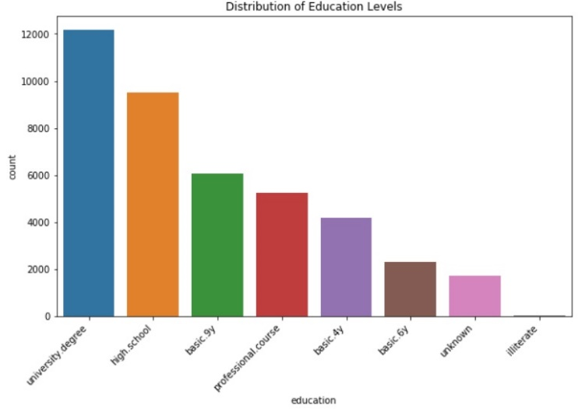
Figure 6: Distribution of Education Levels

Machine Learning
The process begins with initializing a Spark session and loading the dataset into a PySpark DataFrame. The dataset is then split into training and test sets for model evaluation. PySpark's DataFrame abstraction provides a distributed and efficient way to handle large-scale data.

The machine learning pipeline involves the use of PySpark's machine learning modules, specifically the StringIndexer for indexing categorical labels, the VectorAssembler for assembling feature vectors, and the DecisionTreeClassifier for building the decision tree model. The StringIndexer is employed to transform the categorical label column into a numerical format, while the VectorAssembler combines the features into a single vector.

A key step in the pipeline is shown in the code in the figure below. The code transforms the label column, which typically represents the outcome variable into a format suitable for machine learning classification tasks. The label is converted from categorical values ("yes" or "no") to binary integers (0 or 1). This step is crucial for algorithms that require numeric labels.

Figure 7: Column Transformation

The decision tree model is set up with specified label and feature columns, and the training data is used to fit the model. The labeled data is indexed, and the decision tree classifier is trained on this indexed data. This approach allows for the interpretation of results in terms of labeled categories.

The pipeline concludes with model evaluation using PySpark's MulticlassClassificationEvaluator. Accuracy and F1-score metrics are computed to assess the performance of the decision tree classifier on the test data. This robust evaluation process ensures that the model's predictive capabilities are thoroughly assessed.

Our model reported the following metrics: an Accuracy of approximately 91.05% and an F1-Score of around 89.91%. The high accuracy implies that the Decision Tree classifier successfully predicted whether a client would subscribe to a term deposit or not for most instances. The high F1-score indicates a strong balance between the precision (accuracy of positive predictions) and recall (ability to capture all positive instances) of the classifier.

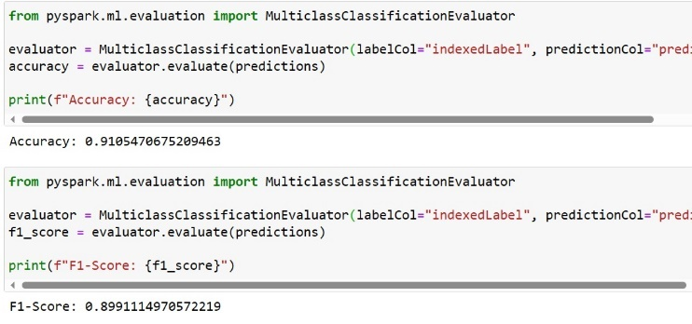
Figure 8: Code and Output for Evaluation Metrics

Table 2: Model Summary

Metric | Score
Accuracy | 91.05%
F1-score | 89.91%

Conclusion
Machine learning applied to marketing data from a prominent Portuguese bank reveals a powerful approach for understanding client behavior. Leveraging PySpark, MongoDB, and a decision tree classifier, our study explores term deposit subscriptions. The decision tree model, achieving an accuracy of approximately 91.05% and an F1-score of around 89.91%, goes beyond predictions, offering transparency into factors influencing client decisions. From preprocessing with PySpark to model evaluation, this project exemplifies the seamless synergy between scalable computing and advanced analytics in banking. The interpretability of the model adds depth, providing actionable insights for informed decision-making. This comprehensive exploration not only enriches marketing strategies but also lays the groundwork for future endeavors in data-driven insights, contributing to transformative approaches in the ever-evolving landscape of banking.

Acknowledgment

The authors wish to thank Professor Erton Boci for his support throughout this semester and his guidance throughout this project. His insightful lectures and expert advice played a pivotal role in shaping our understanding of the subject matter.

Limitations

While the project provides valuable insights into client interactions, it is not without limitations. The dataset exhibits an inherent imbalance in subscription rates, with a notable prevalence of instances where clients did not subscribe to term deposits. Additionally, reliance on a single dataset source may introduce representation biases, limiting the broader generalizability of findings across diverse demographic groups within the Portuguese population. Furthermore, the dataset's temporal scope is confined to a specific timeframe (2008 to 2010), potentially overlooking dynamic trends or seasonality in banking behaviors that could vary over different periods. These limitations underscore the importance of cautious interpretation and acknowledgment of the dataset's constraints in shaping the outcomes of our analyses and machine learning analysis. Additionally, the current implementation is not fully automated. It requires user intervention to initiate the machine learning processes. Future work may focus on optimizing and automating these processes to enhance efficiency and user-friendliness.

References

- G. Barilla, “History of Machine Learning: How We Got Here,” akkio, Sep. 23, 2023. Available: https://www.akkio.com/post/history-of-machine-learning
- T. Drabas, D. Lee, and H. Karau, Learning PySpark : build data-intensive applications locally and deploy at scale using the combined powers of Python and Spark 2.0. Birmingham, UK: Packt Publishing, 2017.
- M. Masum et al., "Scalable Machine Learning Using PySpark," 2022 IEEE 46th Annual Computers, Software, and Applications Conference (COMPSAC), Los Alamitos, CA, USA, 2022, pp. 454-455, doi: 10.1109/COMPSAC54236.2022.00087.
- J. Brownlow, C. Chu, G. Xu, B. Culbert, B. Fu and Q. Meng, "A Multiple Source based Transfer Learning Framework for Marketing Campaigns," 2018 International Joint Conference on Neural Networks (IJCNN), Rio de Janeiro, 2018, pp. 1-8, doi: 10.1109/IJCNN.2018.8489772.
- Y. Yu, F. Zhong-liang, Z. Xiang-hui and C. Wen-fang, "Combining Classifier Based on Decision Tree," 2009 WASE International Conference on Information Engineering, Taiyuan, China, 2009, pp. 37-40, doi: 10.1109/ICIE.2009.12.
- H. R. Bittencourt, D. A. de Oliveira Moraes and V. Haertel, "A binary decision tree classifier implementing logistic regression as a feature selection and classification method and its comparison with maximum likelihood," 2007 IEEE International Geoscience and Remote Sensing Symposium, Barcelona, Spain, 2007, pp. 1755-1758, doi: 10.1109/IGARSS.2007.4423159.
- P. Y. Prasad, A. S. Chowdary, C. Bavitha, E. Mounisha and C. Reethika, "A Comparison Study of Fraud Detection in Usage of Credit Cards using Machine Learning," 2023 7th International Conference on Trends in Electronics and Informatics (ICOEI), Tirunelveli, India, 2023, pp. 1204-1209, doi: 10.1109/ICOEI56765.2023.10125838.
- I. Vejalla, S. P. Battula, K. Kalluri and H. K. Kalluri, "Credit Card Fraud Detection Using Machine Learning Techniques," 2023 2nd International Conference on Paradigm Shifts in Communications Embedded Systems, Machine Learning and Signal Processing (PCEMS), Nagpur, India, 2023, pp. 1-4, doi: 10.1109/PCEMS58491.2023.10136040.
- K. N. Myint and Y. Y. Hlaing, "Predictive Analytics System for Stock Data: methodology, data pre-processing and case studies," 2023 IEEE Conference on Computer Applications (ICCA), Yangon, Myanmar, 2023, pp. 77-82, doi: 10.1109/ICCA51723.2023.10182047.
- K. Pahwa and N. Agarwal, "Stock Market Analysis using Supervised Machine Learning," 2019 International Conference on Machine Learning, Big Data, Cloud and Parallel Computing (COMITCon), Faridabad, India, 2019, pp. 197-200, doi: 10.1109/COMITCon.2019.8862225.
- “UCI Machine Learning Repository,” archive.ics.uci.edu. Available: https://archive.ics.uci.edu/dataset/222/bank+marketing

